DAY-21 (24/7/2025)
Emp ID : 110714877
NAME :Kinnera venkatamma

Liskov Substitution Principle 👍

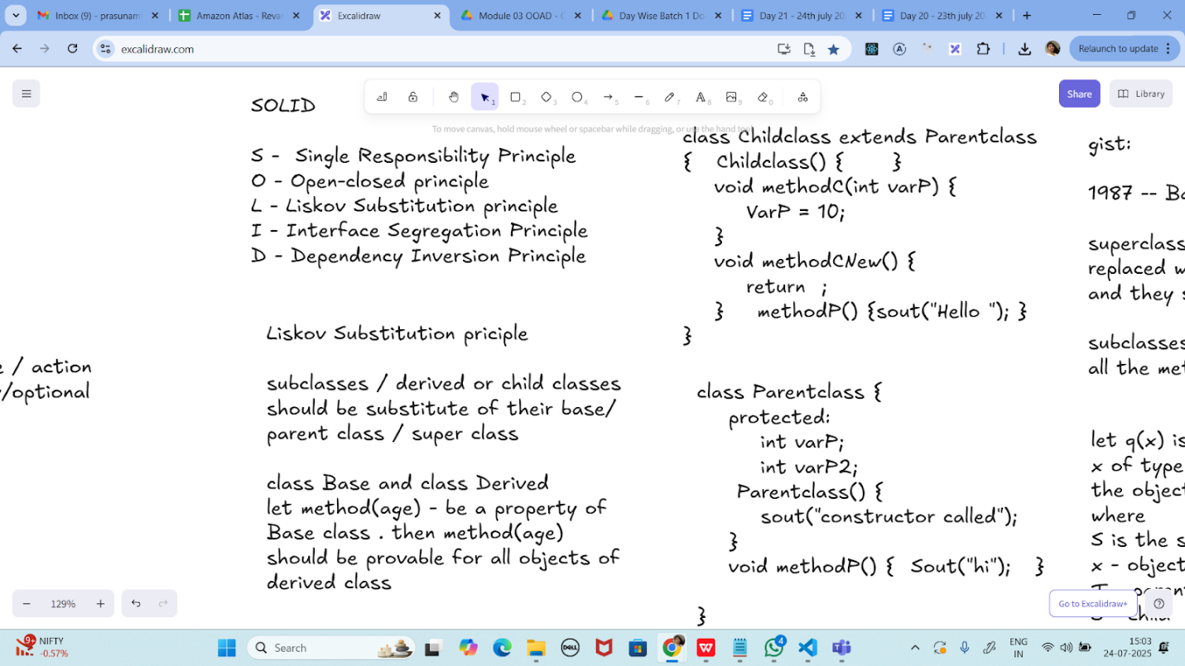

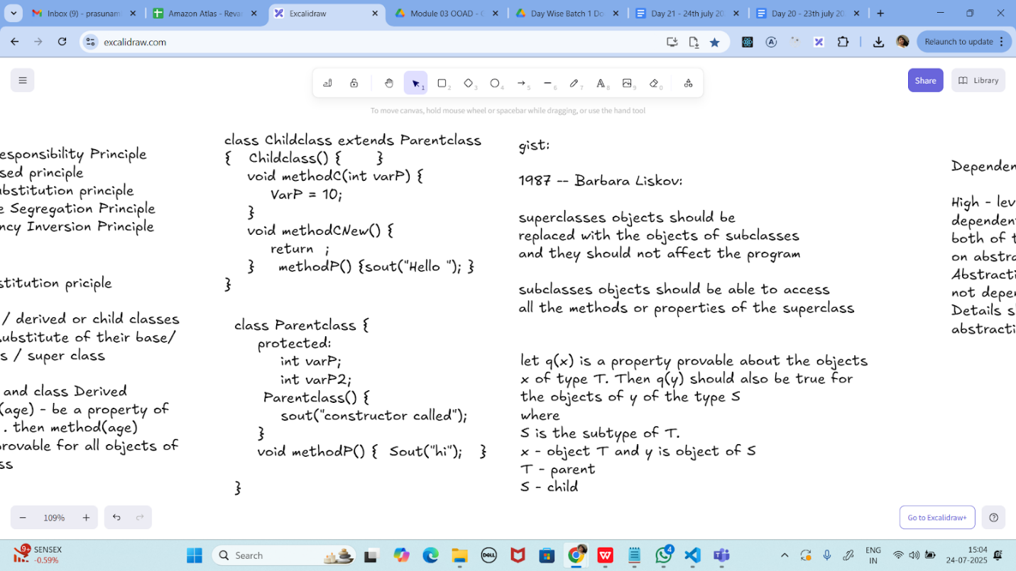

Task 01:
class Animal {
void sound() {
sout(" sounds of different animals");
}
}
class Cat extends Animal{
@Override
void sound() {
sout(" Meow is the sound of cat");
}
}
class Main{
psvm(String[] args) {
Animal obj = new Cat();
obj.sound(); //Meow is the sound of cat
}
}
issue with Substitution and Generics

Java Generics -- it has introduced a challenge - substitution principle...

is cat a subtype of Animal, List<cat> is not a subtype of List<Animal>

List<Cat> Cobj = new ArrayList<>();
List<Animal> Aobj = Cobj; ===// this will give you a wildcard ,

wildcards:

1. unbounded Wildcard
? ===> any data type if you want to use you can use ?

2. Bounded Wildcards with an upper bound (? extends Type)

===> yopu will use it when you need to accept a type and its own subtypes

3. Bounded Wildcards with an lower bound (? super Type)
===> you will use when ypou need accept a type and its super types

Unbounded wildcards:
Task 02:
they are useful whern the code does not depends on the actual type parmeter

void printList(List<?> list) {
for(Object element: list) {
sout (element);
}
}

List<Cat> clist = new ArrayList<>();
clist.add(new Cat());
printList(clist); //

---------------------------
Task 03:

Upper Bounded Wildcards

void animalSound(List<? extends Animal> animalList) {
for(Animal elements : animalList
elements.sound();
}
}
List<Cat> cats = new ArrayList<>();
cats.add(new Cat());
animalSound(cats); //meow

----------------------------
Task 04:

lower Bounded Wildcards

void addAcat(List<? super Cat> cats) {
cats.add(new Cat());
}
List<Animal> animals = new ArrayList<>();
addAcat(animals); //

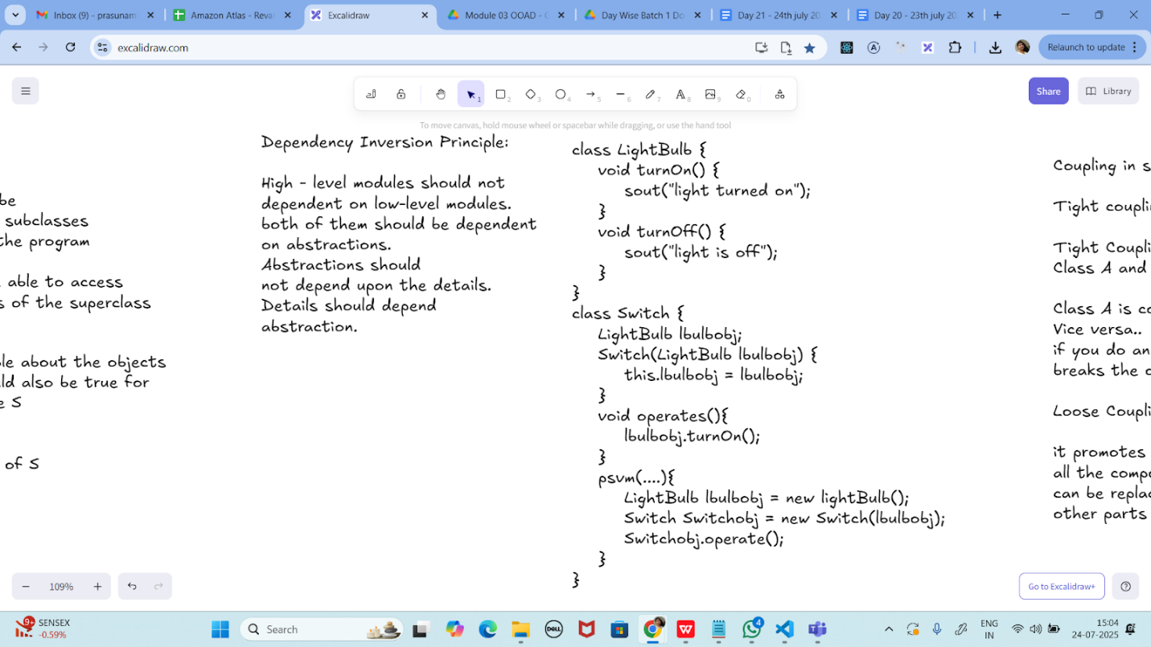

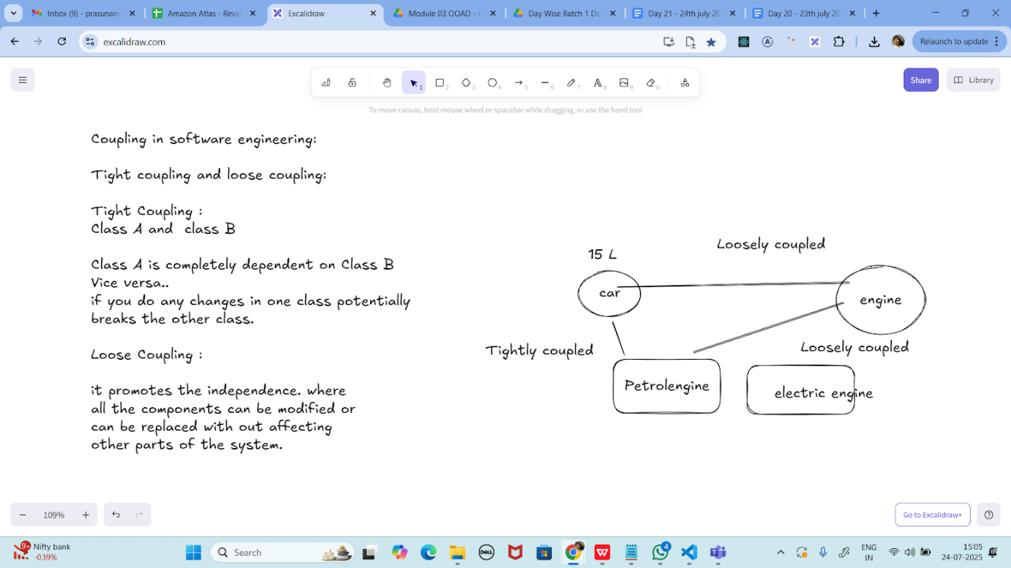
Task 05:

// tight coupling

class Student {
public int roll_no = 10;
//private int roll_no = 10; // this code breaks...
public int getRoll() {
sout("getRoll method");
return roll_no;
}
public void setRoll(int roll) {
if(!(roll > 100)
roll_no = roll;
}
}
class Tight_coupling {
psvm(String....) {
Student sobj = new Student();
sobj.roll_no = 10; // we are not following the rule of Student class roll no > 100..
//sobj.roll_no = 110;
sout("the roll no of student is "+ sobj.roll_no); // 110 // private - error //10
}
}

Task 06:

// loose coupling

class Student {
private int roll_no = 0;
public int getRoll() {
sout("getRoll method");
return roll_no;
}
public void setRoll(int roll) {
if(!(roll > 100)
roll_no = roll;
}
}
class Loose_coupling {
psvm(String....) {
Student sobj = new Student();// Person pobj = new Student(); // person got a bonus
sobj.setRoll(10);
sout("the roll no of student is "+ sobj.getroll();
}
}

/*

Module 1 Module 2 Module 3
independent .. they do communicate

// we should do coupling -- importance

good maintainability
testability
Error propagation
high coupling - errors and it will propagate throught the project.. not at all recommandable..
reusability:

No coupling :

the modules wont interact with eachother.. -- completely independent..

*/

Task 07:

//DIP violating

class LightBulb {
void turnOn() {
sout("light turned on");
}
void turnOff() {
sout("light is off");
}
}
class Switch { // switch class directly depends on the lightbulb class ---- DIP violating
LightBulb lbulbobj;
Switch(LightBulb lbulbobj) {
this.lbulbobj = lbulbobj;
}
void operates(){
lbulbobj.turnOn();
}
psvm(....){
LightBulb lbulbobj = new lightBulb();
Switch Switchobj = new Switch(lbulbobj);
Switchobj.operate();
}
}

Task 08:

DIP implementation:

interface SwitchOnOff {
void turnOn();
void turnOff(); // void remoteControl();// void alexaVoiceControl();
}
class LightBulb {
void turnOn() {
sout("light turned on");
}
void turnOff() {
sout("light is off");
}
} // or class fan, class inverter, class washing machine...(in future remote for washing machine
// i can extend without modification..
class Switch { // switch is depending on switchonoff class not on light bulb..
SwitchOnOff device;
void Switch(SwitchOnOff device) {
this.device = device;
}
void operates() {
device.turnOn();
}
}
class DIP {
psvm(....){
SwitchOnOff lbulbobj = new LightBulb();
Switch lightswitch = new Switch(lbulbobj);
lightswitch.operate();
}
}

Association, Composition, Aggregation, Inheritance
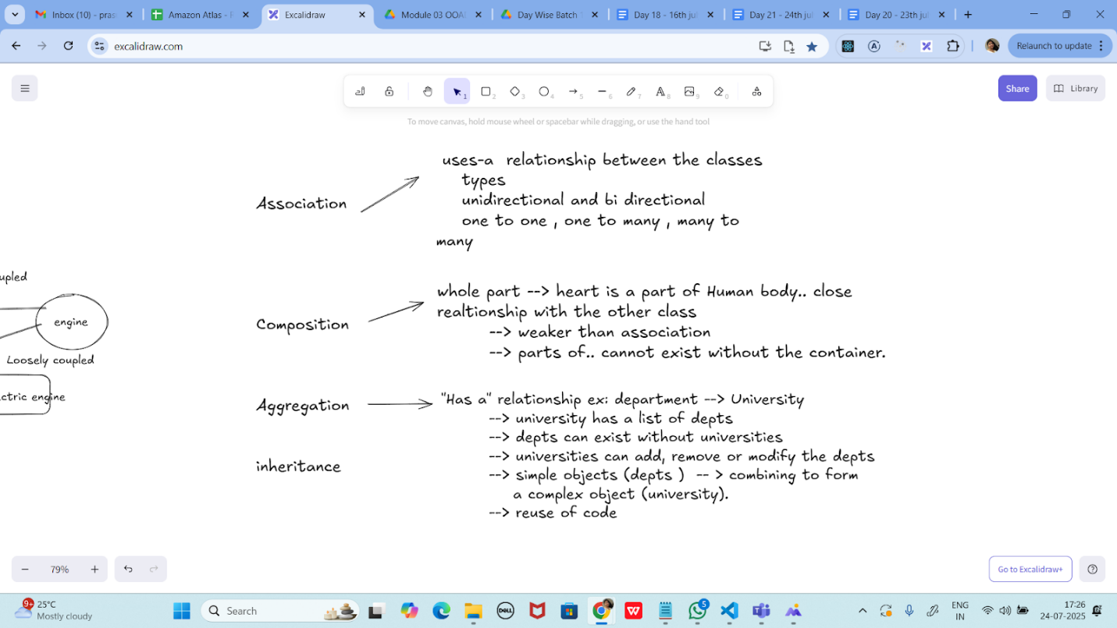

Task 09:

Why should we choose Composition over Inheritance?

Loose coupling

Flexibility

Better encapsulation

UML representation

